Nanjing University
limited
A dissertation for bachelor’s degree
of engineering


The Design and Implementation of Event-flow model of GUI-based Applications for testing

Author’s Name： Hou Xiaokun
Specialty： Software Engineering
Supervisor： Chen Zhenyu
Finished time: May 28th，2012

Abstract
Graphical user interfaces (GUIs) are playing an important role in today’s software and their correct execution is required to ensure the correctness of the overall software. A popular technique to detect defects in GUIs is to test them by executing test cases and checking the execution results. Test cases may either be created manually or generated automatically from a model of the GUI. While manual testing is unacceptably slow for many applications, and the cost of creating a GUI model is very high.
Here I will implement a newly proposed model called GUI forest and the event-flow graphs. And they can be generated directly from the executable GUI with reverse engineer method. [1][2]The tool can capture the structure of the software’s GUI through traversing the AUT by opening all its windows and extracting all their widgets (GUI objects), properties, and values. Then with the GUI structure, it will create an event-flow graph. In this article, I will present the core algorithm and the model data structure. Also I will describe the implementation of the tool based on Java-GUI.

Keywords：Java, EFG, GUI, Test Automation, JAXB
Contents
Abstract I
图目录 III
Chapter I Introduction 1
1.1 Background 1
1.2 Automation test development status and trends 1
1.3 My Work 2
1.4 Structure of the Article 3
Chapter II Technology Overview 4
2.1 Test Automation 4
2.2 XML 4
2.3 JAXB 4
2.4 MVC 5
Chapter III Requirement Analysis and High Level Design 6
3.1 Basic Knowledge 6
3.1.1 GUI 6
3.1.2 GUI Forest 6
3.1.3 Flow of Events 7
3.2 Requirement Analysis 8
3.2.1 GUI 抓取需求分析 8
3.2.2 生成EFG的需求分析 9
3.2.3 系统性能需求分析 9
3.3 High Level Design 10
Chapter IV Detail Design and Implementation 11
4.1 Detail Design of GUI Capture Subsystem 11
4.1.2 Core Algorithm 11
4.2 GUI抓取子系统的实现 13
4.2.1 GUIStructure实现 13
4.2.2 算法实现 14
4.3 EFG子系统的设计 16
4.3.1 Event-flow Graphs事件流图 16
4.3.2 事件类型 16
4.3.3 EFG生成核心算法 17
4.4 EFG子系统的实现 17
4.4.1 EFG实现 17
4.4.2 算法实现 19
第五章 总结与展望 20
参考文献 21
致谢 23

图目录
图2.1 Java 平台体系结构图 5
图2.2 JAXB 处理流程 7
图2.3 MVC 结构图 8
图3.1 GUI抓取用例图 10
图3.2 EFG生成用例图 12
图3.3系统概要设计 13
图3.4 GUI抓取时序图 14
图4.1记事本的GUI森林 15
图4.2 组件抓取核心算法 16
图4.3 GUI数据结构实现 18
图4.4 GUI抓取详细类图 18
图4.5记事本部分EFG表示 20
图4.6 EFG生成算法 20
图4.7 EFG实现 22
图4.8生成EFG详细类图 23

Chapter I Introduction

Background
The graphical user interfaces as a kind of good interactive way have been applied widely in common applications and software industries. The user experience is being taken seriously by more and more people and GUI code takes as high as 60% of the whole code. UI testing decides whether user experience is good or not and the quality of software directly.
GUI testing has been widely used in software industry. The current UI testing requires a lot of artificial participation, including writing test cases, running test case, and the testing result analysis, etc. The tools used are mostly typical record \ replay tools. It requires users manually to record operation and then save as test cases script, at last playback and compare with baseline. But what matters is that testing scripts are generated manually, and also there exists scripts maintenance problems.
There has been some research which is trying to build a suitable model to automatically generate test cases. For example, goal-directed search for GUI test case generation, function composition for automated test-oracle creation , metrics from graph theory to define test coverage criteria for GUIs, graph-traversal to obtain smoke test cases for GUIs that are used to stabilize daily software builds, and graph matching algorithms to repair previously unusable GUI test cases for regression testing, etc. But these models have limitations, narrow focus or the generation cost is too high.
Here we will adopt the event-flow graph model to realize the test cases generation automatically. [1][2]

1.2 Automation test development status and trends
There are two general approaches to test automation. One is code-driven testing and the other is graphic user interface testing. Here we will only talk about the GUI testing (or UI testing).
Below are some popular GUI testing tools in the industry:
Rational Robot is the industry's top function testing tool. With it the tester can do a successful test before learning advanced testing technology. It is integrated in testers’ desktop IBM Rational Test Manager. In it testers can do plan, organization, implementation, management and report all Test activities, including manual Test report. This double function of testing and management is the ideal start of test automation.
Win Runner is a kind of an enterprise-level functional test tool for inspecting whether the application is running as expected. Through the automatic capture, detection, and repeating the operation of the user interaction, Win Runner can identify weaknesses and ensure that no failures in the first release when cross multiple applications or several business processes of database, and maintain long-term reliable operation.
QuickTest Professional is a function test automation tool, mainly applied in regression testing. QuickTest focuses on the GUI application, including the traditional Windows applications, and Web applications that become more and more popular. It can cover most technology of the software development, simple and efficient, and have the test cases reusable characteristics. Its functions includes create test, insert the checkpoint, inspect data, enhancement test, test execution, results analysis and test maintenance, etc.
AdventNet QEngine is a widely used and platform-independent software test tool, can be used for Web function test, Web performance test, Java application function test, SOAP test, Java API test, regression test and Java application performance test. It support HTML, JSP, ASP, .net, PHP, JavaScript/VBScript, XML, SOAP, WSDL, e-commerce, traditional client/server application test. This tool use Java development, so that be friendly to transplantation and provide multi-platform support.
SilkTest…
QARun…
Test Partner…
All the tools are using the typical record and playback mode and it require testers to manual record test scripts. This is the place where is to be improved. We will create a tool to generate the test cases automatically directly from the application under test.

1.3 My Work
This tool will generate test cases automatically. And I am responsible for realizing the AUT’s GUI capture function, getting the hierarchical structure of the GUI function, and then generating event-flow graph module.

1.4 Structure of the Article
This paper introduces relevant theoretical knowledge about the UI testing and GUI modeling, and it will emphatically describe the design and implementation of Event-flow model of GUI-based applications at last.
Chapter I: Overview and Introduction part, mainly explain the current automated test development and the significance of test cases automatically generated.
Chapter II: Technology overview part. Introduce automation test, as well as the technology involved in the development process.
Chapter III: Requirements analysis and high level system design part. It includes the functional and non-functional requirements and an outline design.
Chapter IV: Detail design part. Describe core algorithm and data structure of the whole project.
Chapter V: Summary of the project part. Talk about the shortcomings and deficiencies of the project, and pointed out the future direction of expansion and development of the project.

Chapter II Technology Overview

2.1 Test Automation
Test automation is the use of software to control the execution of tests, the comparison of actual outcomes to predicted outcomes, the setting up of test preconditions, and other test control and test reporting functions. Commonly, test automation involves automating a manual process already in place that uses a formalized testing process.
There are two general approaches to test automation:
Code-driven testing. The public (usually) interfaces to classes, modules or libraries are tested with a variety of input arguments to validate that the results that are returned are correct.
Graphical user interface testing. A testing framework generates user interface events such as keystrokes and mouse clicks, and observes the changes that result in the user interface, to validate that the observable behavior of the program is correct.

2.2 XML
Extensible Markup Language (XML) [4] is a markup language that defines a set of rules for encoding documents in a format that is both human-readable and machine-readable.

2.3 JAXB
Java Architecture for XML Binding (JAXB) [5] allows Java developers to map Java classes to XML representations. JAXB provides two main features: the ability to marshal Java objects into XML and the inverse, i.e. to unmarshal XML back into Java objects. In other words, JAXB allows storing and retrieving data in memory in any XML format, without the need to implement a specific set of XML loading and saving routines for the program's class structure. Figure 2.2 shows that.
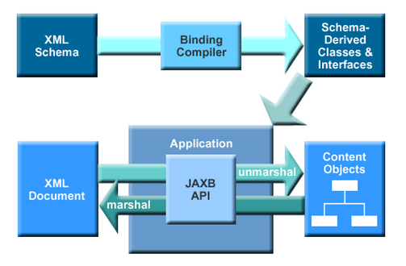
Figure 2.2 Processing Flow of JAXB

2.4 MVC

Controller

View
Module

Figure 2.3 MVC Structure

Chapter III Requirement Analysis and High Level Design

3.1 Basic Knowledge

3.1.1 GUI
GUIs are hierarchical. This hierarchy is reflected in the groups of windows, dialogs or hierarchical menus. The important characteristics of GUIs include their graphical orientation, event-driven input, hierarchical structure, the widgets they contain, and the properties (attributes) of those widgets. See the GUIs of Notepad in Figure 3.1.
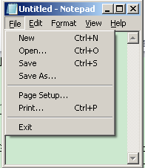
Figure3.1 GUIs of Notepad
3.1.2 GUI Forest
Based on the characteristics of the GUI, GUI forest is created. Intuitively, the GUI forest represents the structure of the GUI’s windows (as nodes of the forest), and the hierarchical relationship between windows (as edges). Each node encapsulates the state of a window that constitutes the window’s widgets, their properties, and values.
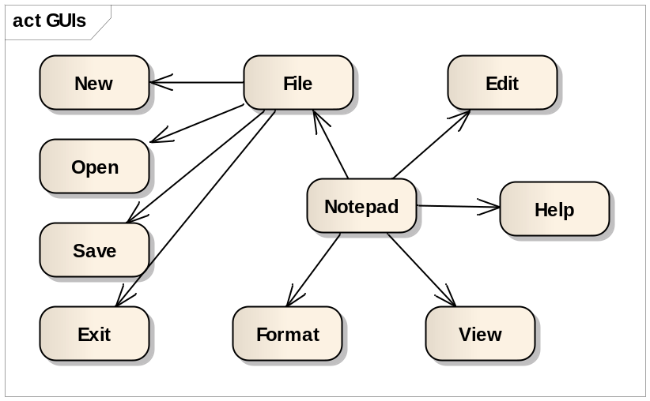
Figure3.2 GUI Forest of Notepad
Figure 3.2 shows the GUI forest (in this case a single tree) for Notepad. Note that the window that is presented to the user when Notepad is launched is called “top-level” (in this case it is Notepad) and forms the root of the tree. All other windows are either invoked from top-level or from one of the child windows.

3.1.3 Flow of Events
The GUI forest in its raw form is not useful for test case generation. We collect additional information during capture the GUI hierarchy to develop new structures that model the GUI’s execution behavior that we call its flow of events. To create the events flow, what matters is to get the set of events can be reachable after an event. To do this, it needs to extract the event type during the GUI traversing process.
The first class of events, called restricted-focus events open modal windows. For example, Set Font is a restricted-focus event. The second class, called unrestricted-focus events open modeless windows. For example, Replace in Notepad is an unrestricted-focus event. Termination events close modal windows; common examples include OK and Cancel.
The GUI contains other types of events that do not open or close windows but make other GUI events available. These events, called menu-open events are used to open menus. They expand the set of GUI events available to the user. Menu-open events do not interact with the underlying software. Note that the only difference between menu-open events and unrestricted-focus events is that the latter open windows that must be explicitly terminated. For example, in Notepad, File and Edit are menu-open events.
Finally, System-interaction events interact with the underlying software to perform some action; common examples include the Copy event used for copying objects to the clipboard.
An example of an event-flow graph for the Notepad is shown in Figure 3.3. The nodes represent events in the component and the edges show the follows relationship.

In the next chapter, we describe the algorithms of the GUI capture process and EFG generation process.

3.2 Requirement Analysis

3.2.1 GUI 抓取需求分析
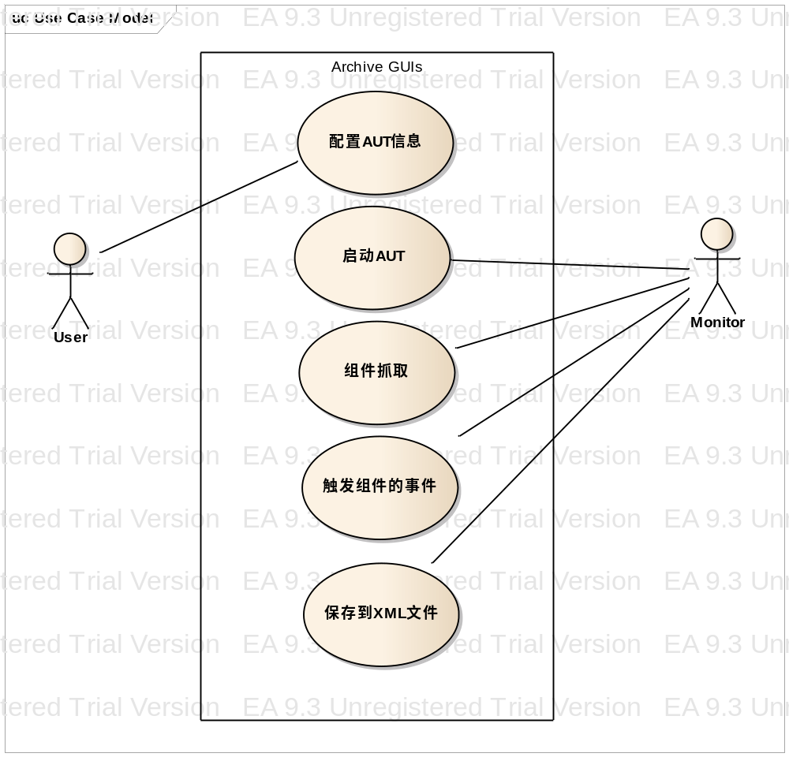
图3.1 GUI抓取用例图

3.2.2 生成EFG的需求分析
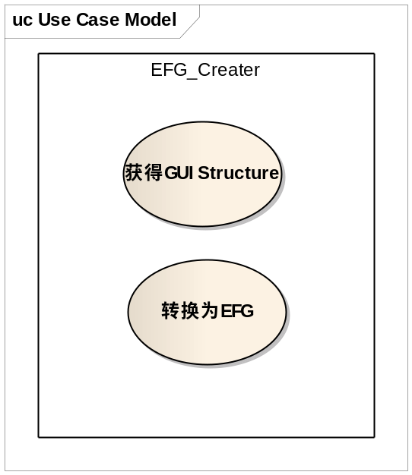
图3.2 EFG生成用例图

3.2.3 系统性能需求分析
对系统的性能需求分析如下：
精度：系统对于精度要求不高，系统出现异常或错误会输出相应的错误提示。
时间特性要求：
1 响应时间：Monitor模拟的触发事件间的间隔是可控的。
2 爬取时间：与具体被测程序复杂程度相关
3 EFG生成时间： 不会超过1min

3.3 High Level Design
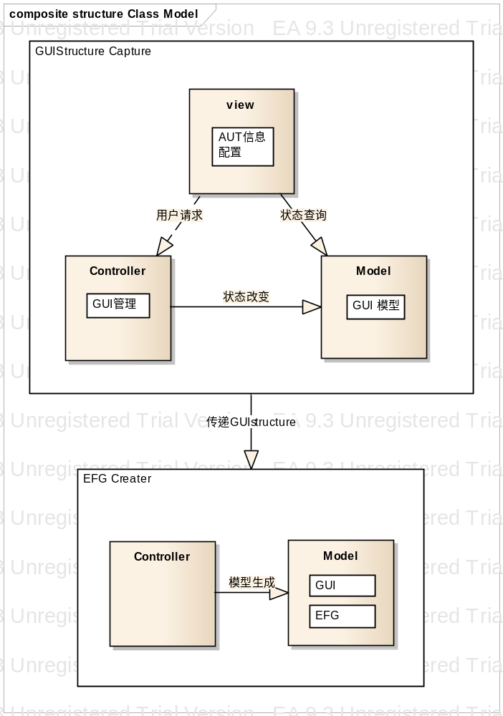
图3.3系统概要设计

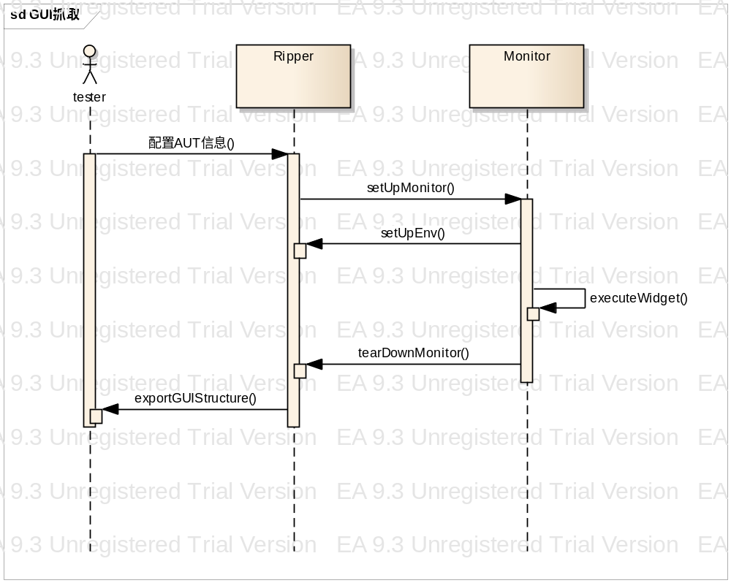
图3.4 GUI抓取时序图

Chapter IV Detail Design and Implementation

4.1 Detail Design of GUI Capture Subsystem

4.1.2 Core Algorithm
As discussed earlier in Chapter 3, the GUI of an application is structured as a forest. We obtain this structure by performing a depth-first traversal of the hierarchical structure of the GUI. See the detail in Figure 4.1.
GUI/*GUI tree of application under test*/
PROCEDURE DFS-GUI(Application A) 1 T=access-top-level-windows(A) 2 GUI=T 3 /*T is set of top-level windows in the application*/
FORALL t∈ T DO 4
DFS-GUI-Recursive(t) 5

PROCEDURE DFS-GUI-Recursive(Window g) 6 W=get-widget-list-and-properties(g) 7
/*W is the set of all widgets in the window*/
E=identify-executable-widgets(W) 8
/*From W identify executable widgets*/
FORALL e ∈ E DO 9
Execute-widget(e) 10
/*Execute the widget e*/
C=get-invoked-gui-windows(e) 11
GUI=GUI ∪ g 12
FORALL c∈C DO 13
DFS-GUI-Recursive(c) 14
Figure 4.1 GUI Traversing and Extracting the GUI of an Application
The function DFS-GUI (line 1) takes an application as an input. The function access-top-level-windows (line 2) return the top-level windows of the application. Then Call the function DFS-GUI-Recursive (line4、5) for every top-level window. A GUI tree is constructed for each of the top-level window by invoking the procedure. At the termination of the algorithm, GUI contains the GUI forest of the application.
DFS-GUI-Recursive traverses a certain window and extracts its structure. The procedure performs a depth-first search for the GUI tree rooted at the GUI window g. In line 7 the call to get-widget-list-and-properties returns a list W of the constituent widgets in the GUI window g. The function identify-executable-widgets in line 6 searches the set W and returns a list of widgets which invokes other GUI windows. This is because not all of the widgets in W invoke other GUI windows.
A widget that invokes other GUI windows is executed by execute-widget in line 10. When executed, e may invoke one or more GUI windows. The function get-invoked-gui-windows in line 11 returns the list of GUI windows invoked by e. Note that each of the GUI windows c in the set C are child nodes of the node g in the GUI tree. The GUI tree GUI is updated in line 12. This is done by inserting each GUI Window c from C as a child node of the GUI window g. Lines 13–14performs a recursive search of the sub-tree rooted at each of the invoked GUI window c.
When the procedure DFS-GUI-Recursive returns to DFS-GUI, the tree rooted at the top-level window t is constructed. At the completion of the procedure DFS-GUI, the complete GUI forest of the application under test is available in GUI.
The algorithm described in Figure 4.1 is general and can be applied to any GUI defined in Chapter 3. Later, we will describe how the high-level functions used in the algorithm and implemented using Java API.

4.2 Implementation of GUI Capture Subsystem

4.2.1 GUI Forest
In Figure 4.2 it shows the data format of GUIStructure with XML schema. With JAXB, it’s convenient to transform the Java object to a formatted xml file.
<!-- GUIStructue root level -->
<xs:element name="GUIStructure">
<xs:complexType>
<xs:sequence>
<xs:element maxOccurs="unbounded" minOccurs="1" name="GUI" type="GUIType"/>
</xs:sequence>
</xs:complexType>
</xs:element>
<!-- Individual GUI representing a window -->
<xs:complexType name="GUIType">
<xs:sequence>
<xs:element maxOccurs="1" minOccurs="1" name="Window" type="ComponentType"/>
<xs:element maxOccurs="1" minOccurs="1" name="Container" type="ContainerType"/>
</xs:sequence>
</xs:complexType>
<!-- A GUI container containing one or more children component -->
<xs:complexType name="ContainerType">
<xs:complexContent>
<xs:extension base="ComponentType">
<xs:sequence>
<xs:element name="Contents" type="ContentsType"/>
</xs:sequence>
</xs:extension>
</xs:complexContent>
</xs:complexType>
<!-- A set of GUI components under a Container -->
<xs:complexType name="ContentsType">
<xs:sequence>
<xs:choice maxOccurs="unbounded" minOccurs="1">
<xs:element name="Widget" type="ComponentType"/>
<xs:element name="Container" type="ContainerType"/>
</xs:choice>
</xs:sequence>
</xs:complexType>
<!-- A GUI container containing one or more children -->
<xs:complexType name="ComponentType">
<xs:sequence>
<xs:element maxOccurs="1" minOccurs="1" name="Attributes" type="AttributesType"/>
<xs:element maxOccurs="1" minOccurs="0" name="Optional" type="AttributesType"/>
</xs:sequence>
</xs:complexType>
<!-- Attributes of a GUI window/component, containing a set of key-values pair GUI properties -->
<xs:complexType name="AttributesType">
<xs:sequence>
<xs:element maxOccurs="unbounded" minOccurs="1" name="Property" type="PropertyType"/>
</xs:sequence>
</xs:complexType>
<!-- Individual key-values pair GUI property -->
<xs:complexType name="PropertyType">
<xs:sequence>
<xs:element maxOccurs="1" minOccurs="1" name="Name" type="xs:string"/>
<xs:element maxOccurs="unbounded" minOccurs="1" name="Value" type="xs:string"/>
</xs:sequence>
</xs:complexType>
Figure 4.2 GUI Forest Data Structure
The root node is the GUIStructure, composed by many GUI elements, each GUI represents a window.
GUI node has two child nodes. The first element is Window, just only one, and describes the basic attributes of the Window. The second part is the Container, also can have only one, and describes the widgets in the window and their attributes.
Container node has two types of child nodes. One is Widget, describes the widgets in the window. The other is Container, describes sub-container in the container. And every widget has a set of key value properties. For example,
ID: widget id
Class：Widget type
Type：Event type
X、Y：Widget location
Title：Widget title
…

4.2.2 Detail
具体实现如图4.4详细类图：
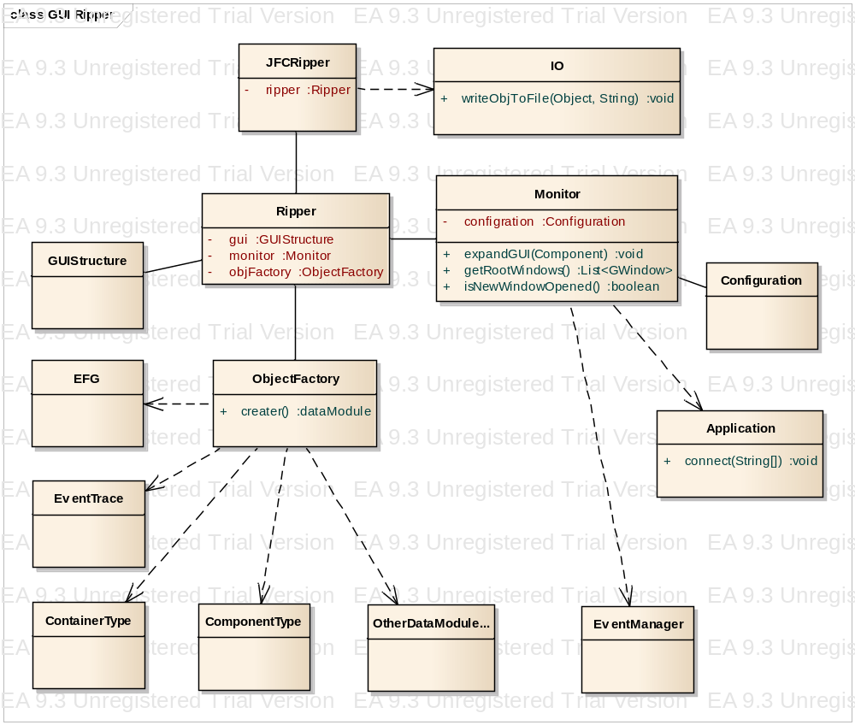
图4.4 GUI抓取详细类图
JFCRipper class is the entrance, have a Ripper object. And after the completion of the grab called within methods will GUIStructure IO written to the file. Ripper is the core of the GUI grasping realization, Ripper has GUIStructure object is used to store grab the GUI structure after, Ripper is also a Monitor object is used to trigger events, environment configuration core operation. Another instance variables objFactory responsible for instance data module of the object, such as EFG, ComponentType and so on. Monitor events of responsible for allocated components, and analyzes the type of event, expandGUI (Component) method will open a new window corresponding to the core of the algorithm line10; GetRootWindows () method for measuring the root of the program for is corresponding to the core of the algorithm window line2; IsNewWindowsOpened () method is used to decide whether to open a new window to determine the type of event. A similar method and some. Events will be five event type, as below. Application package of tested program, used to be the start of the program
JFCRipper类是入口，有一个Ripper对象。并且抓取完成后会调用IO内的方法将GUIStructure写入文件。
Ripper是GUI抓取的核心实现，Ripper中有GUIStructure对象用于存储抓取后的GUI结构，Ripper中还有一Monitor对象用于事件触发、环境配置等核心操作。另一个实例变量objFactory负责实例数据模块中的对象，如EFG、ComponentType等等。
Monitor类负责事件分配给各个组件、并分析事件的类型，expandGUI（Component）方法会打开新的窗口对应于核心算法中的line10；方法getRootWindows()用于获取被测程序的根窗口对应于核心算法中的line2；方法isNewWindowsOpened()用于判断是否打开了新的窗口以判断事件的类型。类似的方法还有一些。会将事件归于5种事件类型，下面会讲到。
Application类封装被测程序，用于被测程序的启动。
EventManager封装事件类型，便于更好的给组件分发事件。
Configuration类用于配置启动被测程序的各种参数。
ObjectFactory类使用简单工厂方法，实例各种module的数据。

4.3 EFG子系统的设计

4.3.1 Event-flow Graphs事件流图
获得GUI结构之后并不能对测试用例的生成带来直接的帮助。需要再转换为EFG模型。
事件流图：相关窗体内的事件之间的关系是可以用一个流图来表示的。对任意一个事件e，如果确定了某些事件可以在e之后立即执行，那么e与这些事件之间的连通关系可以用一条有向边来表示。
当确定了所有事件之间的关系。那么从一个开始事件起按边执行即为一个测试用例。这就是生成测试用例的基本思想。如图4.4一个EFG例子：
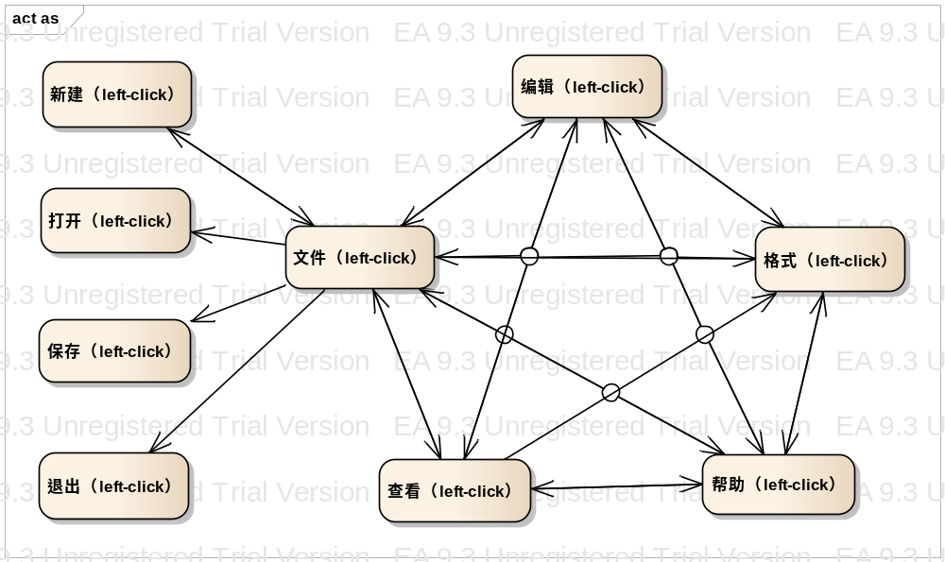
图4.5记事本部分EFG表示

4.3.2 事件类型
获得所有事件的关系生成EFG模型，首先需要将事件归为几类，根据事件的类型分析事件结束后的后续行为。
1） Restricted-focus events 事件触发后生成新的模态框
2） Unrestricted-focus events 事件触发后生成的是非模态框
3） Menu-open events 事件打开菜单
4） System-interaction events 事件不会更新GUI结构，只是触发后台操作
5） Termination events 事件关闭窗口

4.3.3 EFG生成核心算法
下面介绍后的事件e的后续事件的算法，获得后续事件集是绘制事件关系图的关键所在。如图4.4
ALGORITHM： GetFollows(v: Vertex or Event){
IF EventType(v)=menu-open
IF v∈B of newly invoked modal dialogue
return (MenuChoices(v)∪{v}∪B)
ELSE
return MenuChoice(v)∪{v}∪follows(parent(v)))
IF EventType(v)=system-interaction
return(B of current window)
IF EventType(v)=termination
return(B of Invoking modal dialogue)
IF EventType(v)=unrestricted-focus
return(B∪B of Invoked modal dialogue)
IF EventType(v)=restricted-focus
return(B of Invoked modal dialogue)

图4.6 EFG生成算法
GetFollows传入的是一个事件（EFG中的一个顶点）。如果事件类型是menu-open事件，如果事件属于当前的模态框，因为当前事件触发后还可以再触发一次或者触发菜单中的事件或者触发当前模态框中的可触发事件，所以返回菜单内的事件、本事件和当前模态框内的事件。如果事件不属于当前的模态框，则返回菜单内的事件、本事件和使本事件可用的父事件的后续事件（与本事件同级的事件集）。如果事件是system-interaction类型，则返回当前窗口内的事件集。如果事件是termination类型，则返回上一层窗口的事件集。如果事件是unrestricted-focus类型，则返回当前窗口事件集和新创建的窗口的事件集。如果事件是restricted-focus类型，则只返回被调用窗口内的事件集。
此算法会返回某个类型的后续可达事件集，据此可以得到完整的事件流程图。

4.4 EFG子系统的实现

4.4.1 EFG实现
下面为生成的EFG的具体的数据结构，如图4.7是使用XML schema定义的格式，使用JAXB技术可以方便的从schema转换为定义的Java对象、从Java对象转换为符合schema的xml文本。

<!-- EFG root level -->
<xs:element name="EFG">
<xs:complexType>
<xs:sequence>
<!-- Event information -->
<xs:element maxOccurs="1" minOccurs="1" name="Events" type="EventsType"/>
<!-- Edge Adjacency matrix -->
<xs:element maxOccurs="1" minOccurs="1" name="EventGraph" type="EventGraphType"/>
</xs:sequence>
</xs:complexType>
</xs:element>
<!-- Set of events -->
<xs:complexType name="EventsType">
<xs:sequence>
<xs:element maxOccurs="unbounded" minOccurs="1" name="Event" type="EventType"/>
</xs:sequence>
</xs:complexType>
<!-- Individual event -->
<xs:complexType name="EventType">
<xs:sequence>
<!-- Event Identifier in the graph -->
<xs:element maxOccurs="1" minOccurs="1" name="EventId" type="xs:string"/>
<!-- The corresponding widget ID in the GUI file -->
<xs:element maxOccurs="1" minOccurs="1" name="WidgetId" type="xs:string"/>
<!-- Event type: there are 5 type of events considered in the EFG -->
<xs:element maxOccurs="1" minOccurs="1" name="Type" type="xs:string"/>
<!-- Initial event true if the event is available right after the application starts -->
<xs:element maxOccurs="1" minOccurs="1" name="Initial" type="xs:boolean"/>
<!-- Actual action can be performed on the event like click, type text -->
<xs:element maxOccurs="1" minOccurs="1" name="Action" type="xs:string"/>
<!-- Optional: Event name -->
<xs:element maxOccurs="1" minOccurs="1" name="Name" type="xs:string"/>
<!-- Optional: Event listener -->
<xs:element maxOccurs="unbounded" minOccurs="0" name="Listeners" type="xs:string"/>
<!-- Optional: fields for events -->
<xs:element maxOccurs="1" minOccurs="0" name="Optional" type="AttributesType"/>
</xs:sequence>
</xs:complexType>
<!-- EFG edge Adjacency matrix -->
<xs:complexType name="EventGraphType">
<xs:sequence>
<xs:element maxOccurs="unbounded" minOccurs="1" name="Row" type="RowType"/>
</xs:sequence>
</xs:complexType>
<xs:complexType name="RowType">
<xs:sequence>
<xs:element maxOccurs="unbounded" minOccurs="1" name="E" type="BooleanType"/>
</xs:sequence>
</xs:complexType>
<!--
Value of row r_th and column c_th in the EFG edge's Adjacency matrix
- value = 0: no edges
- value > 0: there is an edge from event r_th to c_th in the graph (referred by their
indices in the Event list)
+ 1: Normal edge
+ 2: Reaching edges: the edges that that open a new window or reveal events hidden under the GUI's hierarchical structure (e.g, File -> New).
Those edge are given a higher priority when finding path to reach an event.
-->
<xs:simpleType name="BooleanType">
<xs:restriction base="xs:int">
<xs:enumeration value="0"/>
<xs:enumeration value="1"/>
<xs:enumeration value="2"/>
</xs:restriction>
</xs:simpleType>
图4.7 EFG实现
EFG包括两部分，第一部分是所有的事件即Events元素。第二部分是用邻接矩阵描述所有事件的关系，即EventGraph元素。
每个Event用事件id、对应的组件id、事件类型、被测程序启动后是否立即可用、事件确切的action等等描述。
邻接矩阵中，值是0表示没有边；值非0表示第r_th个事件和第c_th个事件间有一条边。此外，值为1表示两个事件间存在一条普通的边，而值为2表示事件触发后打开了新的窗口或者改变了GUI结构（如下拉菜单等），这种边在寻找事件路径的时候享有更高的优先级，也就是说生成用例的时候会优先寻找这一种。
第一部分描述所有的事件，第二部分描述事件之间的关系。

4.4.2 算法实现
生成EFG如图4.8详细类图：
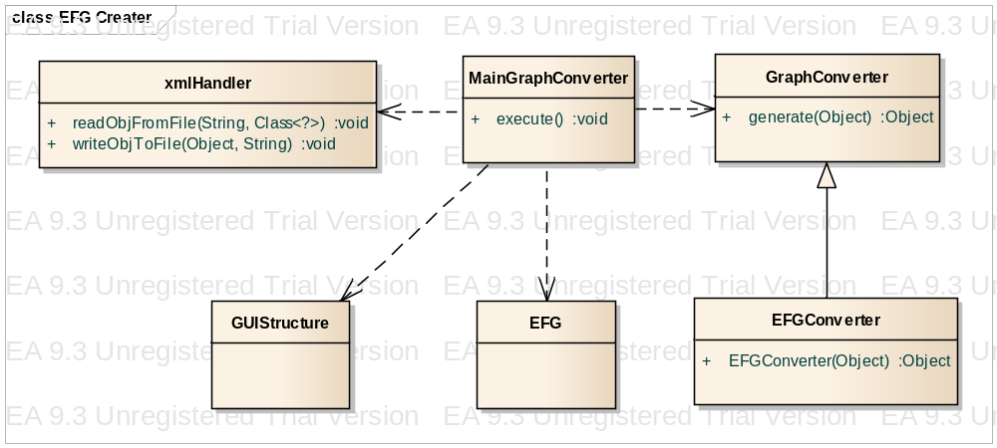
图4.8生成EFG详细类图
MainGraphConverter类中的execute（）方法是入口函数，调用xmlhandler类中的readObjFromFile()方法读入GUIStructure对象，调用EFGConverter中的核心方法EFGConverter()生成EFG对象，最后调用writeObjToFile()方法写入XML文本文件。

第五章 总结与展望
测试用例自动生成的研究在测试领域逐渐被人们所重视，设想仅仅需要载入被测程序，通过自动化工具的分析，直接生成测试用例，对人们工作效率的提高将有巨大的帮助，不再需要反反复复进行脚本的录制、修改和测试用例的编写了。与此同时许多的模型和理论的提出试图在这一方面有所突破，但是往往存在着模型构建代价高昂，工具应用限制多的问题。EFG模型的提出终于带来了一点测试用例自动化的希望。
本文通过对GUI模型的抓取进一步构建事件流程图的一系列研究，基于JAVA-GUI设计和实现了一个EFG自动生成工具。经过测试，EFG模型创建的过程中，完全自动化，操作简单，配置方便，模型稳定，可以完全支持后面测试用例的自动生成。
但是由于时间的仓促和开发人员的不足，系统仍有许多值得改进的地方，在后续的开发中可以考虑如下几方面的改进和完善：
- 增加对输入框、文本框、密码框等需要输入特定文本内容的支持。
- 增强事件间关系强度优先级的支持。
- 增加对鼠标事件、键盘按键事件的支持。
- 增加UI界面，优化用户体验。
- 有些组件的限制，不能抓取到所有的GUI结构。

参考文献
[1] Atif Memon, GUI Ripping: Reverse Engineering of Graphical User Interfaces for Testing
[2] Atif M. Memon,An event-ﬂow model of GUI-based applications for testing
[3] Java, http://zh.wikipedia.org/wiki/Java
[4] XML, http://zh.wikipedia.org/wiki/XML
[5]JAXB, http://www.oracle.com/technetwork/articles/javase/index-140168.html#author
[6] MVC, Eric Freeman, Elisabeth Freeman, Kathy Sierra, Bert Bates. Head First Design Pattern. O’Reilly. 2007

致谢
感谢陈振宇老师给予的指导，正是陈振宇老师的帮助才使得我的毕业设计和毕业论文能够顺利完成。
感谢辅导员曹日喜老师的关爱，他在我的生活和学业上都给予了无微不至的关怀。
感谢软件学院的各位老师，他们不仅传授我知识，更用认真严谨的治学态度深深影响着我。
感谢邹云霄学长，他在整个毕业设计完成阶段给予了我很多帮助和支持。

More information about Rational Robot refers to: http://www-306.ibm.com/software/rational/
More information about Win Runner refers to: http://www-306.ibm.com/software/rational/
More information about QuickTest Professional refers to: http://www-306.ibm.com/software/rational/
More information about AdventNet QEngine refers to: http://www.adventnet.com
More information about AdventNet QEngine refers to: http://www.adventnet.com
More information about AdventNet QEngine refers to: http://www.adventnet.com
More information about AdventNet QEngine refers to: http://www.adventnet.com

